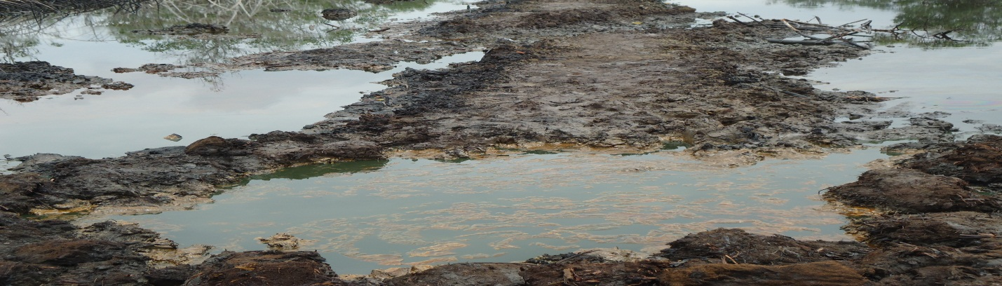Spill point before excavation.
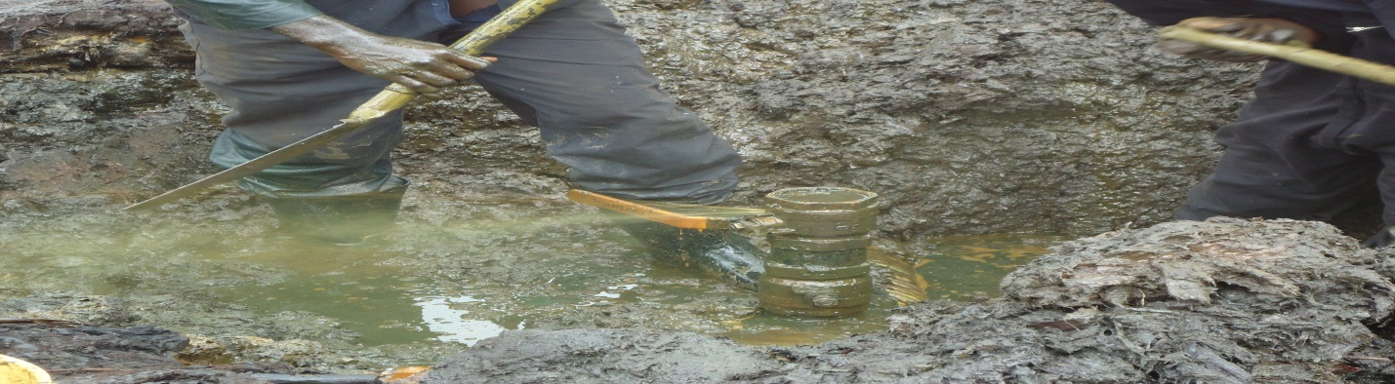Pix showing the cause of spill.
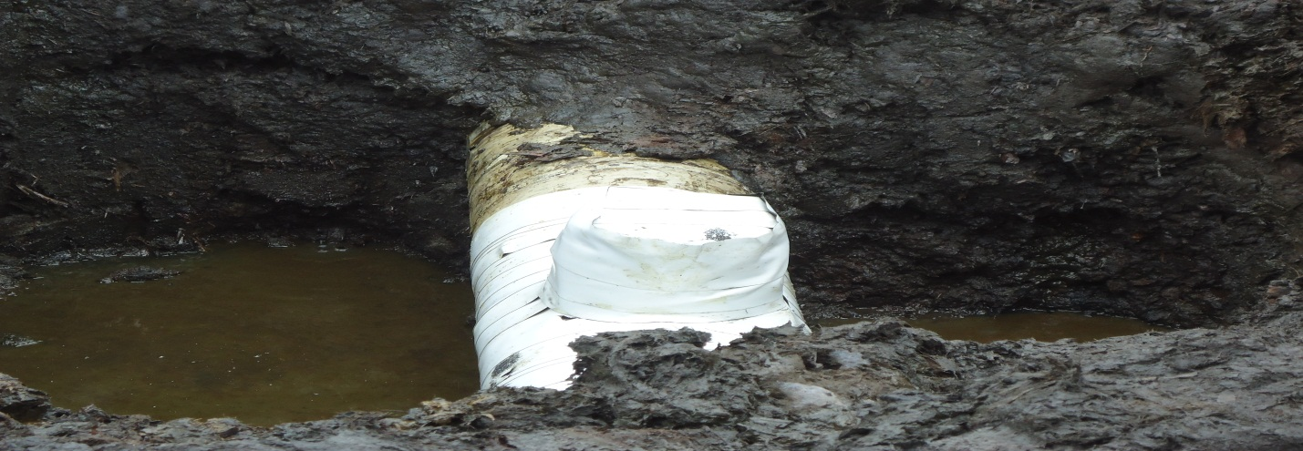
Pix showing point repaired during jiv.

